We have the same dataset company and fraud detection which we handled with decision tree.
Hence we will be applying random forest algorithm on the the company datset to predict the sales

We got 100 % accuracy

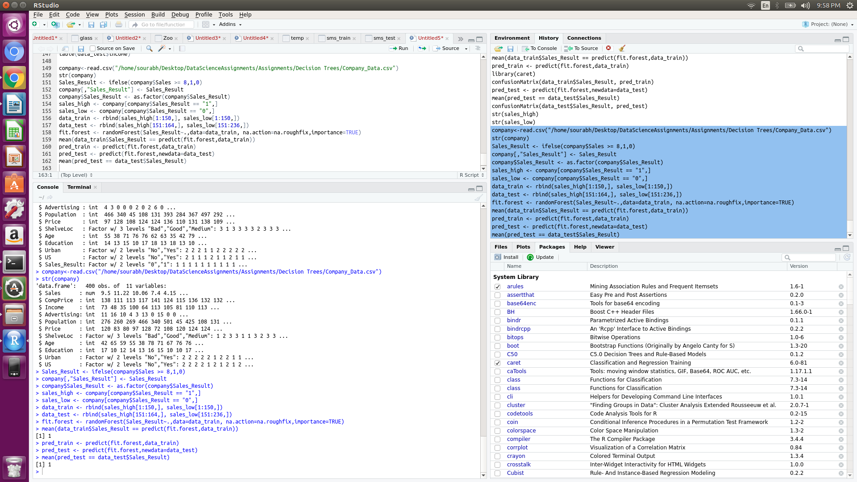
company<-read.csv("/home/sourabh/Desktop/DataScienceAssignments/Assignments/Decision Trees/Company_Data.csv")
str(company)
Sales_Result <- ifelse(company$Sales >= 8,1,0)
company[,"Sales_Result"] <- Sales_Result
company$Sales_Result <- as.factor(company$Sales_Result)
sales_high <- company[company$Sales_Result == "1",]
sales_low <- company[company$Sales_Result == "0",]
data_train <- rbind(sales_high[1:150,], sales_low[1:150,])
data_test <- rbind(sales_high[151:164,], sales_low[151:236,])
fit.forest <- randomForest(Sales_Result~.,data=data_train, na.action=na.roughfix,importance=TRUE)
mean(data_train$Sales_Result == predict(fit.forest,data_train))
pred_train <- predict(fit.forest,data_train)
pred_test <- predict(fit.forest,newdata=data_test)
mean(pred_test == data_test$Sales_Result)

Similary lets work on the fraud detection algorithm

Just like decision tree, we would consider people having taxable income less than 30000 as risky and other good

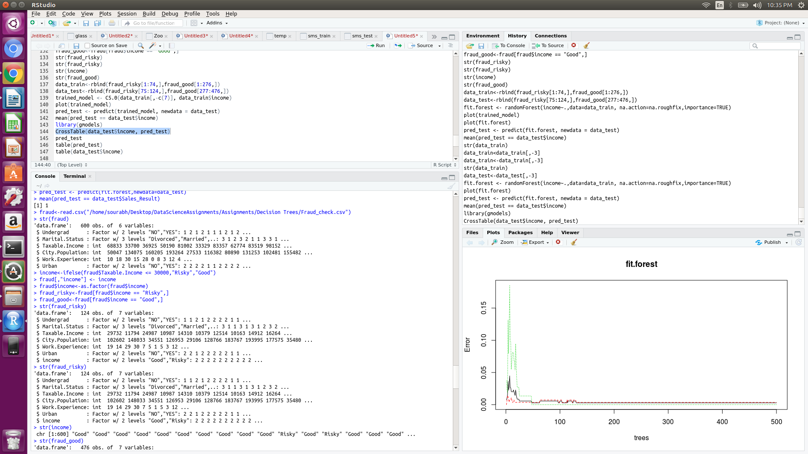
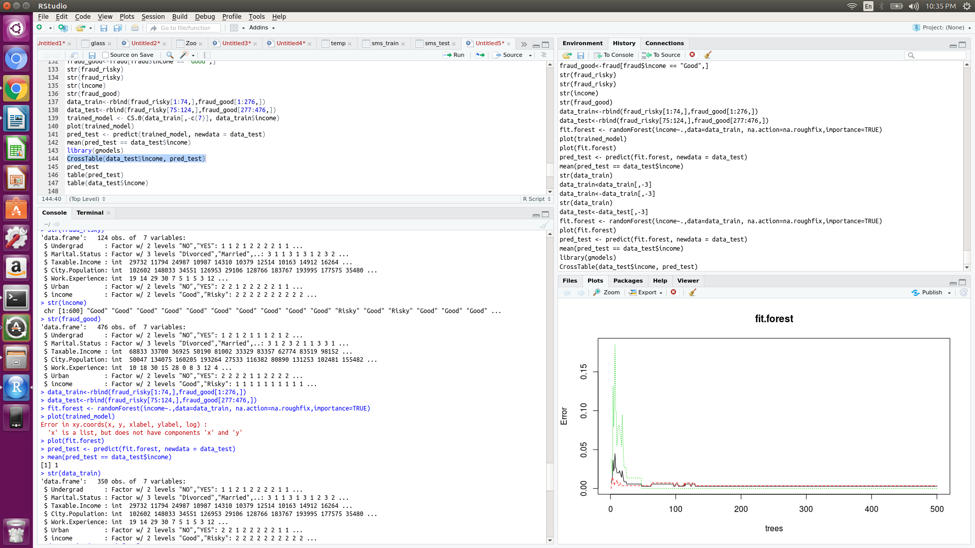

We get the accuracy as 100 % again

code
fraud<-read.csv("/home/sourabh/Desktop/DataScienceAssignments/Assignments/Decision Trees/Fraud_check.csv")
str(fraud)
income<-ifelse(fraud$Taxable.Income <= 30000,"Risky","Good")
fraud[,"income"] <- income
fraud$income<-as.factor(fraud$income)
fraud_risky<-fraud[fraud$income == "Risky",]
fraud_good<-fraud[fraud$income == "Good",]
str(fraud_risky)
str(fraud_risky)
str(income)
str(fraud_good)
data_train<-rbind(fraud_risky[1:74,],fraud_good[1:276,])
data_test<-rbind(fraud_risky[75:124,],fraud_good[277:476,])
fit.forest <- randomForest(income~.,data=data_train, na.action=na.roughfix,importance=TRUE)
plot(trained_model)
plot(fit.forest)
pred_test <- predict(fit.forest, newdata = data_test)
mean(pred_test == data_test$income)

